***Penfolds Magill Estate Shiraz***

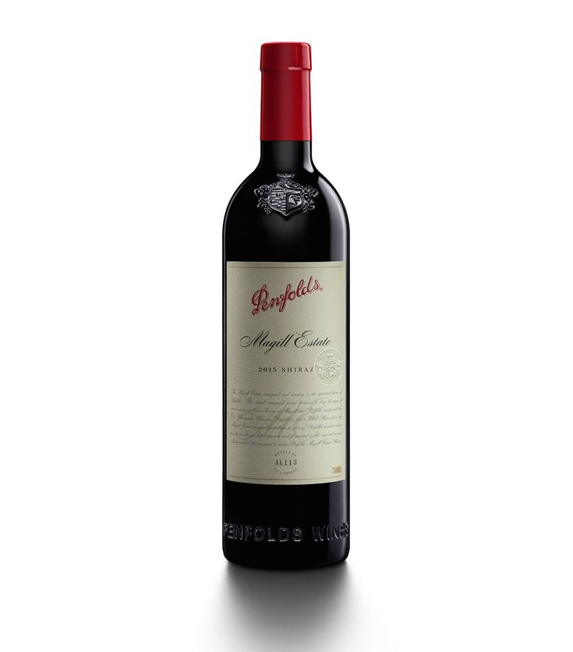

*Penfolds Magill Estate Shiraz Red Wine - made from Shiraz grapes (the soul grape variety of Australian wine) from Magill vineyards on the eastern outskirts of the Adelaide Hills, Australia. The grapes are hand-harvested for production, after fermenting for 17 months in American and French oak barrels.*